Exception handling

Write an application that accepts two numbers, divides the first number with the second number and display the result. Hint: You need to handle Arithmetic Exception which is thrown when there is an attempt to divide a number by zero.

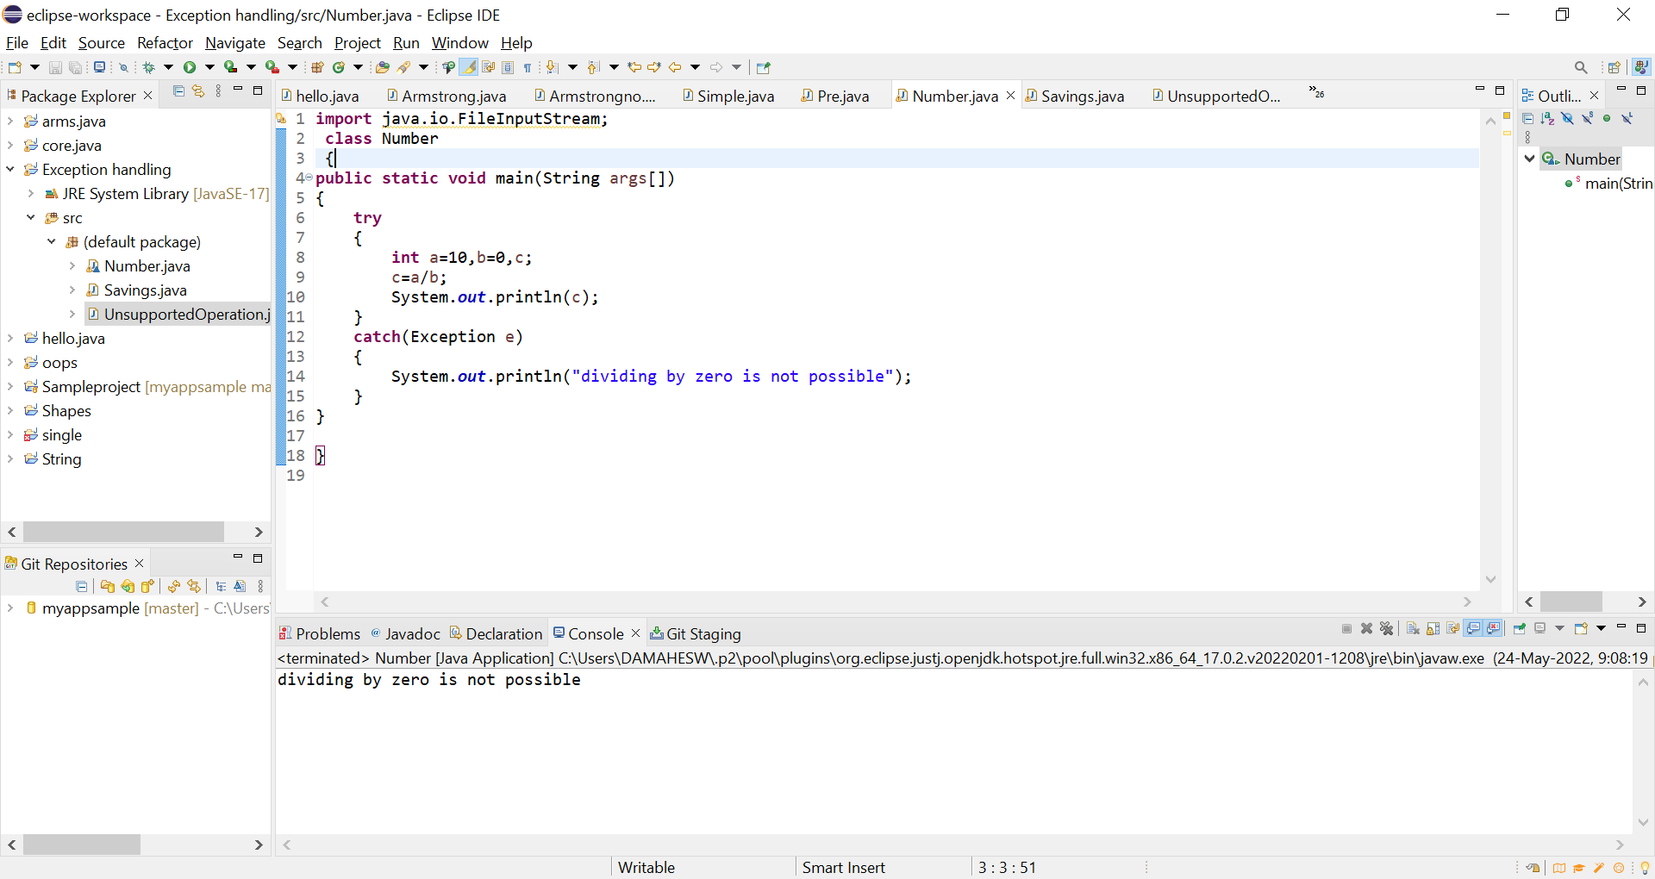

1. Carrying forward with the above problem, handle Arithmetic Exception by raising Unsupported Operation Exception as a solution.

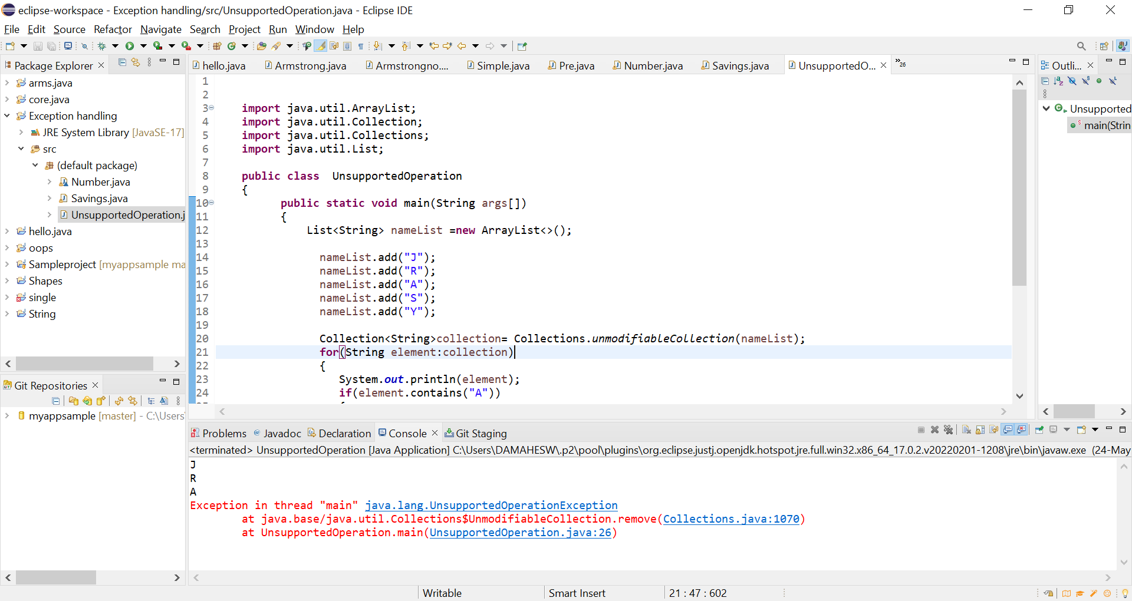

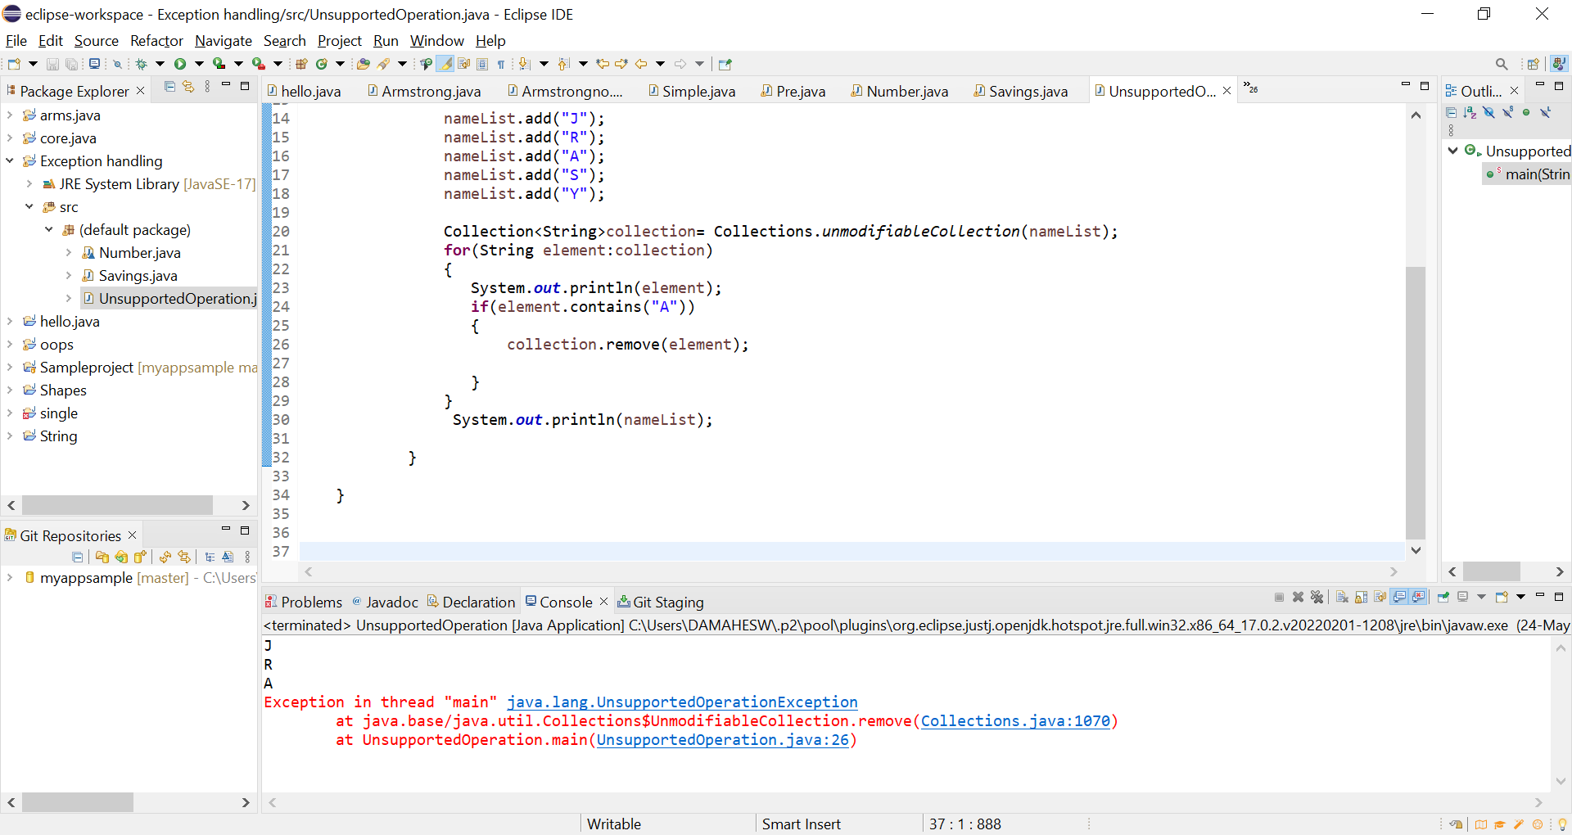

1. Write an application to perform withdraw functionality on a SavingAccount object. Point to note:
2. Raise **Insufficient Balance Exception** if you are trying to withdraw more than balance or when you balance is zero. E.g. if you balance is 2000 and if you are trying to withdraw 2100 or if you balance is 0 and you are trying to withdraw positive value.
3. Raise **Illegal Bank Transaction Exception** if you are trying to withdraw a negative value from your balance. E.g. if you try to withdraw a negative value **saving Acc. withdraw(-1000);**

Note: Saving Account

|-- long id

|-- double balance

|--double withdraw(double amount)

|--double deposit(double amount)

